PRESS RELEASE – 13th December 2022

Watch: Ashgate Hospice nurse gives viewers a glimpse of life inside a hospice during COVID-19
A nurse caring for people at the end of their lives has revealed what it's like working in a busy hospice ward during COVID-19, in a newly released video diary.
Kelly Bartram is a Registered Nurse who cares for patients with palliative and end of life conditions and their families on Ashgate Hospice’s Inpatient Unit.
In her video, she takes viewers on a behind-the-scenes look at what life is like on the charity’s Inpatient Unit; revealing what a 12-and-a-half-hour shift can look like.
From handling the admission of an incredibly unwell patient to discussing the rewarding aspects of caring for families at such a difficult time – the 34-year-old takes viewers on a journey through a day working at the hospice, whilst dispelling some common myths about death, dying and end of life care.
Kelly, who previously worked at Chesterfield Royal Hospital, joined Ashgate 10 months ago as she wanted to use her personal experiences and passion for palliative and end of life care to excel in her profession.
She also has a personal connection to the hospice after her step father-in-law, Tony, spent his final days on the Inpatient Unit where Kelly now works.
Her role includes symptom management, assessing patients, changing medication, providing emotional support to patients and their family and much more.
“From bed baths and toileting to painting nails, applying makeup, and even getting patients a glass of their favourite tipple, we endeavour to ensure families know that nothing is too much trouble!” added Kelly.
“The role is varied and depends a lot on our patients’ needs. Over the past year I’ve found that every day is different, but you are guaranteed some laughter, tears and everything in between!
“We have no control over how the last days of a person’s life will unfold, but I find one of the most rewarding parts of my job is knowing that there is such thing as a good death.
“Knowing we so often manage to achieve comfort and peace at the end of life for our patients, their families and people close to them fills me with an overwhelming sense of achievement.
“The care we provide, the listening, the comfort, the reassurance, and the role we play within their journey is something that families don’t forget.”
Tony, from Chesterfield, was tragically diagnosed with thyroid cancer just six weeks before his death at the hospice.
After being told there was no cure for his condition, he received support at home from Ashgate’s Palliative Care Specialist Nurses, before being admitted to the Inpatient Unit. He died three days later in October 2018, aged 56.
Tony had been in Kelly’s husband Ben’s life since he was just eight years old and was very close with their children before he died.
Despite it being a huge challenge to return to Ashgate’s Old Brampton site for the first time since Tony’s death, Kelly has relished in her first year at Ashgate – admitting that she thinks that end of life care may be her ‘niche’.
She said: “I intentionally hadn’t returned to Ashgate following Tony’s death, my interview for the job was done virtually and I only physically returned when I’d been offered the job.
“I wasn’t sure how I was going to feel. When I arrived, I drove into the car park and sat in my car and had a good cry before finally plucking up the courage to go in.
“Every time I walk past his room I think about him, but it gives me comfort working at Ashgate now – the place we all said our final goodbyes.
“Although I already had a passion for palliative care prior to this experience, initially after his death, I didn’t think I’d ever be able to return to Ashgate, personally or professionally.
“But as time went on and the whole experience felt less raw, I decided that I could use this understanding and this knowledge of being on the “other side” to make me better at my job. It made me stronger and more empathetic as a person and as a nurse.”
Kelly says she is grateful to work for an organisation like Ashgate as she feels well looked after by her work colleagues and the wider organisation.
She added: “I had come to a bit of a standstill with my career and was ready for a change and a new challenge, when the job at Ashgate came up I just knew I needed to apply! I really felt as though this could be my niche.
“I feel like everyone at Ashgate really cares. I am well supported emotionally, and I am believed in and encouraged to keep being the best version of myself.
“I’ve loved the first 10 months of my job so far and I’m looking forward to seeing what happens in 2022!”
Go behind-the-scenes with Kelly and watch her video diary here: A day in the life of an Ashgate Hospice Inpatient Unit Nurse
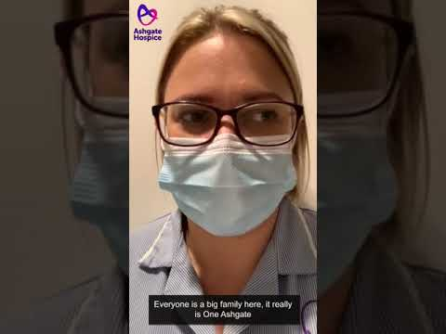
Right now, Ashgate Hospice is calling for the urgent support of the community as the charity faces another difficult winter due to an increase in COVID-19 cases and winter flu.
The hospice is asking the community to support its Winter Appeal to help it to get through the difficult months ahead – ensuring the hospice can continue to provide compassionate end of life care at a crucial time and support the wider health system as it did last year.
To support Ashgate Hospice’s Winter Appeal go to: https://ashgatehospice.org.uk/winter-appeal

-ENDS-

For more information please contact:
Tom Oakley, Communications Officer
07917542665
tom.oakley@ashgatehospice.org.uk

Notes for editors:
- Ashgate Hospice, based in Chesterfield, provides specialist palliative and end of life care including a wide range of community-based care and support services for people with a life-limiting illness and their families across North Derbyshire and the High Peak and Dales. www.ashgatehospice.org.uk

