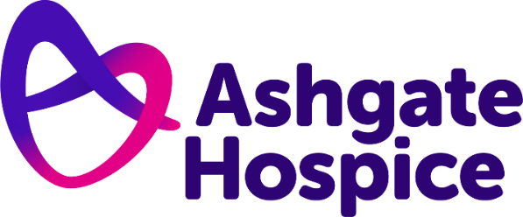

Ashgate Hospice Press Release
14th June 2022

Ashgate Hospice helps grandmother fulfil dying wish of seeing grandson get married
A grandmother defied doctors and fulfilled her dying wish to see her beloved grandson get married – thanks to the support of Ashgate Hospice.
Sheila Elkins, from Pilsley in Chesterfield, was diagnosed with stage four lung cancer in January 2022. After learning the cancer had spread along her spine, Sheila was given just three months to live.
For her family, including daughter Jayne Marks, aged 54, the news was devastating.
Despite the shocking diagnosis, Sheila’s biggest worry was whether she would be around to see her grandson get married, which had been planned for next year.
They were able to rearrange the wedding to 7th May so that she could be there on her grandson’s special day.
Sadly, just over three weeks after the wedding, Sheila died at home on 3rd June with her loved ones by her side.
Jayne said: “Some doctors said she wouldn’t make it. It was a struggle to find another wedding venue at such short notice, but one was found, and the wedding was moved to May in the hope she could attend.”
In the lead up to the wedding, Sheila’s health suddenly took a turn for the worse and she was admitted to hospital with sepsis and pneumonia.
On three occasions Jayne was told that her mother was going to die but miraculously Sheila pulled through.
Although feeling better Sheila was still very unwell and was admitted to Ashgate Hospice's Inpatient Unit for round-the-clock care. Despite receiving support from Ashgate’s community team, Sheila was dreading being admitted as an inpatient.
Jayne said: “She was expecting it to be morbid, but she just turned a corner. They have high expectations for everyone and they make the patients believe they can achieve things.
“They lift patients’ and families’ spirits and make things seem possible again. The care is incredible, and everyone is so cheerful and kind.
“When mum arrived at the hospice, she was barely eating and couldn’t sit up for more than an hour. In just a few days, she started to eat three meals a day, and was chatting and joking with staff. She started to look forward to the wedding again.
“She was still very poorly, but the amazing thing about the hospice staff was that they knew my mum wanted to get to the wedding.
“They even had it in her notes that it was what she wanted to do, and they would do everything they could to get her there. Everything they did was about getting her better for the wedding.”
Sheila was discharged from the Inpatient Unit a few days before the wedding and was helped on the day by a special wheelchair that Ashgate’s Occupational Therapy team provided. This enabled her to sit comfortably throughout the wedding day.
Jayne added: “When it came to the wedding, they gave her an all singing, all dancing wheelchair that meant my mum could be comfortable for long periods of time. They even allowed her to have it for some time afterwards, so it meant we could take her for a day to Chatsworth.
“So many amazing nurses and doctors worked hard to help mum get to the wedding and we are so grateful for the joy that has brought to all of us in the midst of so much pain and sadness.”
For more information about Ashgate Hospice go to www.ashgatehospice.org.uk

–ENDS–

For more information please contact:
Tom Oakley, Communication Officer
07950 958069
tom.oakley@ashgatehospice.org.uk

Notes for editors:
- Ashgate Hospice, based in Chesterfield, provides specialist palliative and end of life care including a wide range of community-based care and support services for people with a life-limiting illness and their families across North Derbyshire and the High Peak and Dales. www.ashgatehospice.org.uk

