Ashgate Hospice Press Release
10th June 2022

Nurses invited to Ashgate Hospice’s recruitment open day for on-the-spot interviews
Nurses are invited to a recruitment open day in Chesterfield where they can have an on-the-spot interview for their next role without pre-applying at a unique open day this summer.
The charity is inviting nurses and other healthcare professionals to learn more about working in end-of-life and palliative care at the recruitment day on Thursday 30th June. The charity is running two free-to-attend sessions from 1pm – 3pm and 5pm – 7pm.
The drop-in sessions will take place at the hospice's site in Old Brampton, Chesterfield, and attendees will be able to interview on the day for the following positions:
- Nurse
- Nursing Associate
- Ward Sister
- Healthcare Assistant
It comes in the wake of a national nursing shortage which is impacting healthcare providers across the UK.
Registered Nurse, Kelly Bartram, who has been caring for patients on the Inpatient Unit charity for just over a year, says working for the hospice “fills her with an overwhelming sense of achievement”.
She said: “I had come to a bit of a standstill with my career and was ready for a change and a new challenge, when the job at Ashgate came up I just knew I needed to apply. I really felt as though this could be my niche.
“From bed baths and toileting to painting nails, applying makeup, and even getting patients a glass of their favourite tipple, we endeavour to ensure families know that nothing is too much trouble.
“Knowing we so often manage to achieve comfort and peace at the end of life for our patients, their families and people close to them fills me with an overwhelming sense of achievement.”
Kelly, who previously worked at Chesterfield Royal Hospital, added: “I feel like everyone at Ashgate really cares. I am well supported emotionally, and I am believed in and encouraged to keep being the best version of myself.
“I’ve loved the first year or so of my job and I’m looking forward to seeing what happens in the future!”
On the day, attendees will get the opportunity to speak to current nurses, the HR team and clinical leads to find out how rewarding a career at Ashgate can be.
They will also receive a tour of the premises, including the hospice’s beautifully landscaped gardens.
Director of People and Performance at Ashgate, Matt Corbishley, added: “We’re looking forward to welcoming healthcare professionals to Ashgate later this month so they can find out more about the many benefits of working for the hospice.
“From speaking to our wellbeing team about how we look after our staff to discussing career progression opportunities and how we can help you carve out your future – you’ll be sure to get a flavour of what working at the hospice is like!
“Please do consider registering on our website and coming along to the recruitment day – we hope to see you there!”
Anyone interested in attending must register their interest by ordering an e-ticket for the event in advance.
Parking at the hospice is free and refreshments will be available on the day too.
If you would be interested in having an interview on the day, please email aimee.bagshawe@ashgatehospice.org.uk with your preferred time slot and the role you are interested in.
Find out more about the open day and register for one of the sessions here: https://ashgatehospice.org.uk/open-day/
Hear from Ashgate Hospice’s staff in the charity’s new video as they discuss what working at the hospice means to them:
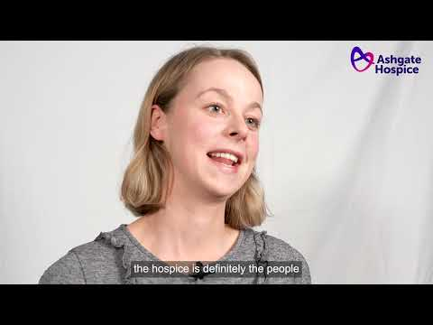

–ENDS–

For more information please contact:
Catherine Maddy, Head of Marketing and Communications
07736934963
catherine.maddy@ashgatehospice.org.uk

Notes for editors:
Ashgate Hospice, based in Chesterfield, provides specialist palliative and end of life care including a wide range of community-based care and support services for people with a life-limiting illness and their families across North Derbyshire and the High Peak and Dales. www.ashgatehospice.org.uk

