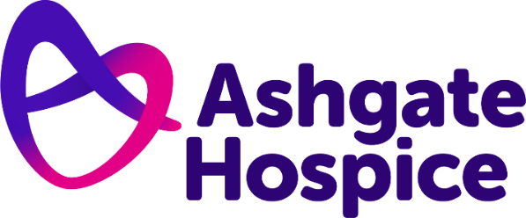

Ashgate Hospice Press Release
22nd July 2022

New LGBT+ rainbow crossing unveiled at Ashgate Hospice

A zebra crossing at Ashgate Hospice has undergone a colourful transformation to celebrate diversity and show support for the LGBT+ community.

The North Derbyshire charity painted the vibrant new rainbow pedestrian crossing outside its Inpatient Unit in Old Brampton, Chesterfield.

It is just one of a handful of ways the hospice has been demonstrating its support and allyship for patients, staff, volunteers and supporters from the LGBT+ community.

Ashgate will also have a stall at Chesterfield Pride on 24 July and are working with Derbyshire LGBT+ to deliver inclusion and awareness sessions to their workforce, as well as decorating its site and shops in rainbow colours.

It comes after the charity recently appointed an Equality Diversity and Inclusion Lead, Liz Allam, who works across the organisation to ensure the hospice and its care is inclusive and accessible for everyone.

She said: “The new crossing will remind everyone who visits us about our support for the LGBT+ inclusion, and our overall commitment towards equality, diversity and inclusion. It is a symbol of our dedication to be open to everyone who needs us.

“Everyone has the right to be treated with dignity and respect and have access to high-quality palliative and end of life care in a safe and inclusive environment.

“We know from research that people from the LGBT+ community are under-served by hospices and may well be under-represented in our staff and volunteers.

“It is important that everyone in our community knows that Ashgate Hospice is an open and inclusive organisation where they will be warmly welcomed.”

Ashgate Hospice invited John Yates-Harold from Derbyshire LGBT+, Councillor Ed Fordham and Councillor Martin Thacker MBE as well as staff and volunteers to officially unveil the new crossing on 21st July.

At the unveiling of the crossing John Yates-Harold, said:

“It means so much to arrive somewhere and see the rainbow, it means I can come here and know that I am welcome. From the flags adorned in the reception, to this vibrant and visual crossing, it shows that I can come here and be myself.”

Local businesses Trustseal Ltd and Geveko Markings supported the hospice through the installation and donation of materials to create the crossing.

The work was carried out free-of-charge saving the hospice more than £3,000, which can be redirected to fund patient care.

Liz added: “We are delighted to have been joining in with the Pride celebrations this year and we’re particularly looking forward to being back at Chesterfield Pride this weekend – please make sure you come and say hello!

“Ashgate has a hugely committed and compassionate workforce and by welcoming staff and volunteers with diverse backgrounds we will enhance and strengthen the organisation further.

“We all work incredibly hard to be welcoming and open at Ashgate, but we know that more can be done.

“We must understand the barriers that some groups may face in accessing us and then work to address those across the organisation.”

Find out more about Ashgate Hospice’s equality, diversity and inclusion commitments here: https://ashgatehospice.org.uk/equality-diveristy-inclusion

– ENDS –

For more information, please contact:
Catherine Maddy, Head of Marketing and Communications
07736934963
catherine.maddy@ashgatehospice.org.uk

Notes for editors:
Ashgate Hospice, based in Chesterfield, provides specialist palliative and end of life care including a wide range of community-based care and support services for people with a life-limiting illness and their families across North Derbyshire and the High Peak and Dales. www.ashgatehospice.org.uk

