Ashgate Hospice Press Release
11th July 2022

Streets of Chesterfield lit up for Ashgate Hospice’s Sparkle Night Walk
Thousands of fundraisers lit up the streets of Chesterfield at Ashgate Hospice’s annual Sparkle Night Walk, sponsored by Vertu Toyota over the weekend.

Donning flashing bunny ears and pink outfits, more than 2,000 people stepped out for the return of the hospice’s biggest fundraiser on Saturday 9th July.

The 10k walk is expected to raise over £200,000 to help fund the end of life care and support the charity provides across North Derbyshire.

The event began and finished at Chesterfield Football Club's Technique Stadium, with walkers setting off at 10pm and live entertainment starting the party at 7.30pm.

Amongst those taking part was Mick Winfield, 67, from Chesterfield who was walking in memory of his brother, John who died in the care of the hospice at just 39 years old.

Mick said: “This is my third time taking part in Sparkle Night Walk and I keep coming back to support the hospice because of the excellent care they gave my brother. Everything they did was perfect, and I just want to give something back for what they did for my brother and my family.”

Another person walking was 57-year-old Julie Lodge and her friend Jane Fox, both from Chesterfield. Julie was walking in memory of her mum, dad and friend Frank who had died just a few weeks earlier.

Julie said: “Ashgate Hospice has been there to support me and my family several times. They were there to care for my dad when he was living with lung cancer, and they were there again when my mum was diagnosed with pancreatic cancer.

“Most recently my friend Frank was cared for on their Inpatient Unit and again the care was phenomenal. I am lucky that I am fit and healthy and I just want to be able to give something back to those who are less fortunate than me.”

Jack Wood, Head of Fundraising at Ashgate Hospice, said: “From everyone at Ashgate, thank you to every person who turned out to take part in our Sparkle Night Walk and made it such a success.

“It’s incredible to see so many people coming together and we were amazed to see over 2,000 people sparkling for their community!

“We know that many people taking part are doing so in memory of their loved ones, many of whom were supported by Ashgate. That shared experience adds to the sense of community and creates a wonderful atmosphere, where people support one another.

“I would also like to praise everyone behind the scenes, including an army of incredible volunteers across the entire route and our generous sponsors for covering so many of our costs.

“Without them, we simply wouldn’t be able to organise such a large and exciting event for the people of North Derbyshire.”

Super early bird registration for next year’s event has opened, with the walk set to take place on Saturday 1st July 2023.

To find out more about next years Sparkle Night Walk and to register for the super early bird price of £7 go to: www.ashgatehospice.org.uk/sparkle-night-walk

Watch a special thank you video from the night Sparkle Night Walk 2022 - Thank you!
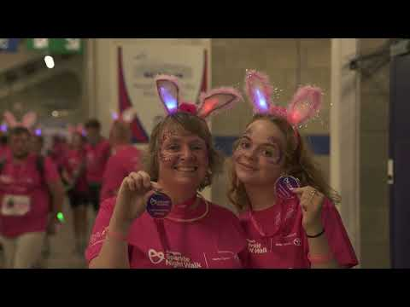

–ENDS–

For more information, please contact:
Catherine Maddy, Head of Marketing and Communications
07736934963
catherine.maddy@ashgatehospice.org.uk

Notes for editors:
Ashgate Hospice, based in Chesterfield, provides specialist palliative and end of life care including a wide range of community-based care and support services for people with a life-limiting illness and their families across North Derbyshire and the High Peak and Dales. www.ashgatehospice.org.uk

